# Exercise: JavaScript for Front-End

Problems for exercises and homework for the "[JavaScript Applications" course @ SoftUni](https://softuni.bg/courses/js-apps)

## Job Application

Create the following page using [Bootstrap](https://getbootstrap.com/) and the plugins – [Collapse](https://getbootstrap.com/docs/4.1/components/collapse/), [Social Buttons](https://lipis.github.io/bootstrap-social/), [SweetAlert](https://lipis.github.io/bootstrap-sweetalert/) and [Dropify](http://jeremyfagis.github.io/dropify/).

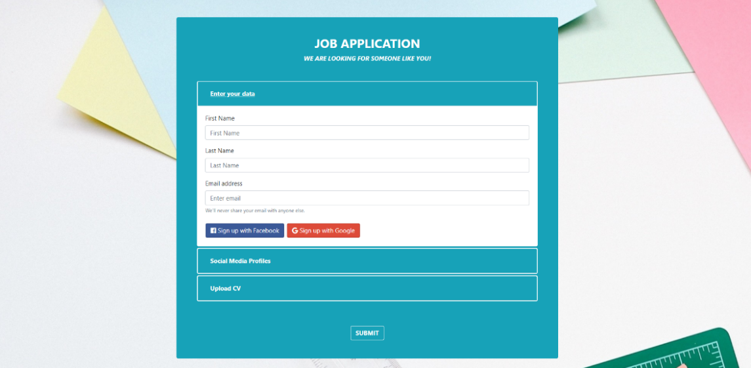

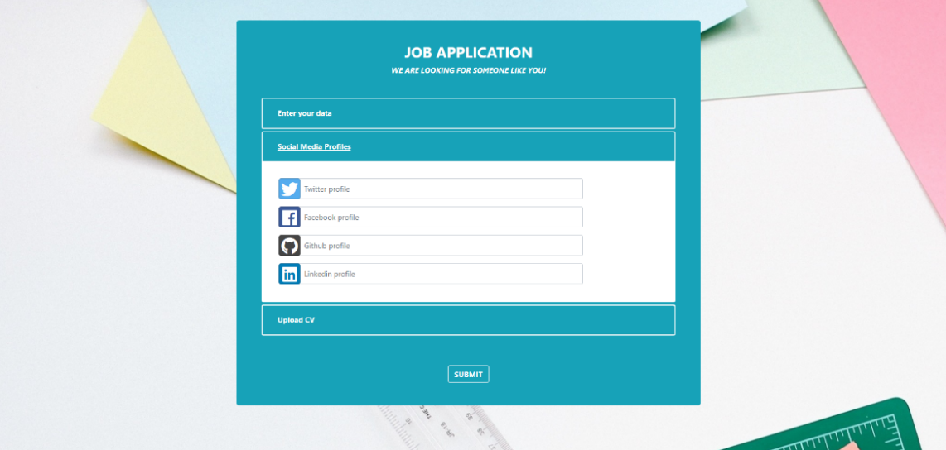

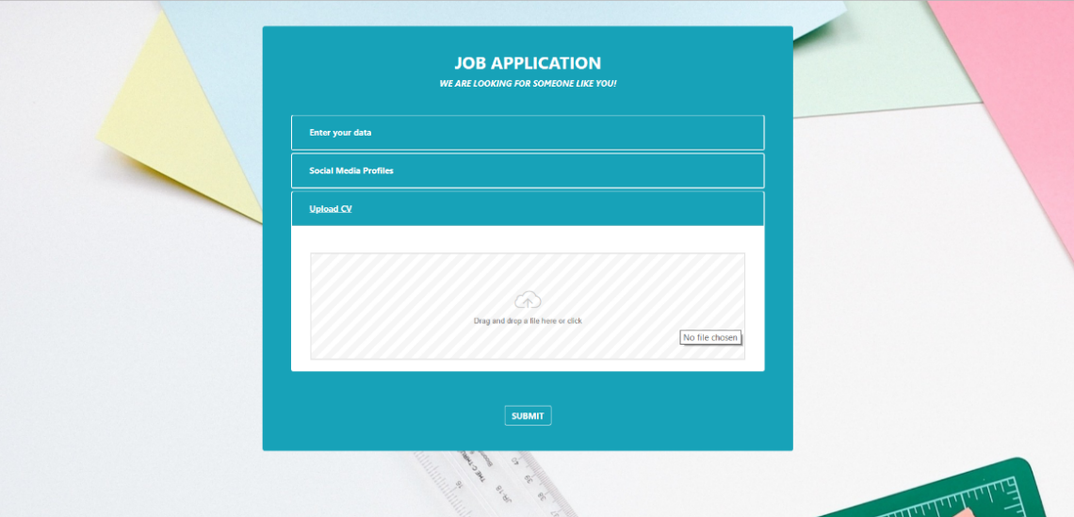

### Your task

You will be given some **resources** (images and screenshots). On that base you must implement the **front-end part** by using **HTML**, **CSS** and **Bootstrap** and the logic to attach events on all the **buttons**.

### Personal data section

Use [Bootstrap](https://getbootstrap.com/) to create a simple form in the **first section** and add **two** **buttons** for **sign** **up**.   
The **buttons** should be **styled** using the [Social Buttons](https://lipis.github.io/bootstrap-social/) plugin.

Upon **clicking** **one** of them you should **show** a **notification** using the [SweetAlert](https://lipis.github.io/bootstrap-sweetalert/) plugin.

The **first section** should look like this:

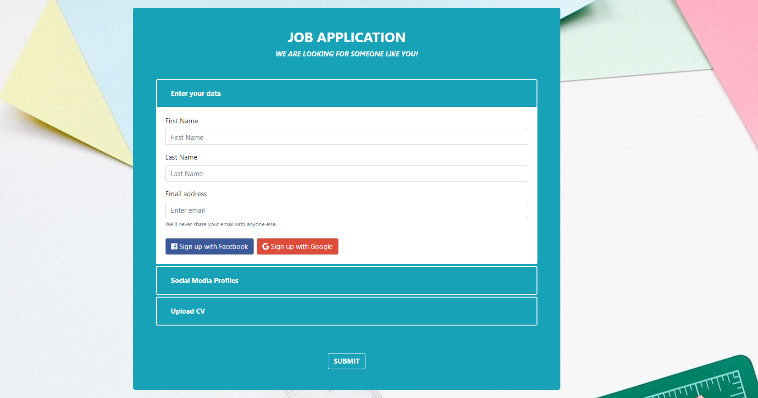

The **notification** you should show upon clicking one of the “social buttons” should look like this:

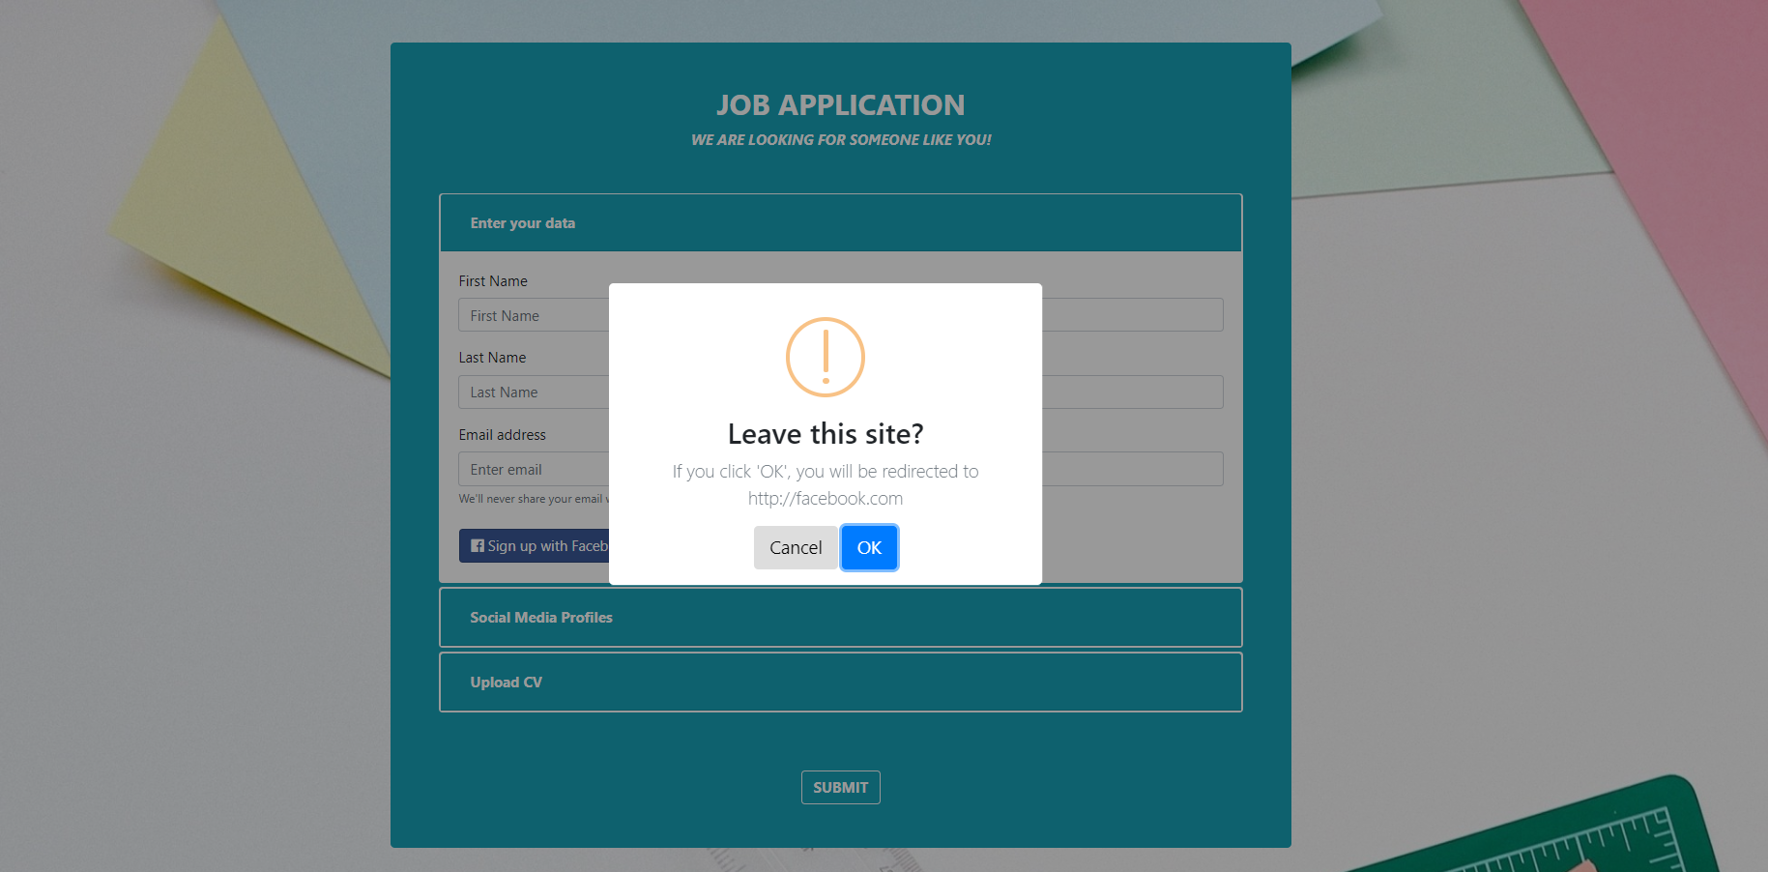

### Social Media Section

This is the **second section**. It should have **4 input fields** for **social media accounts** andtheyshouldbestyledusing the[Social Buttons](https://lipis.github.io/bootstrap-social/) plugin.

The **second** **section** should look like this:

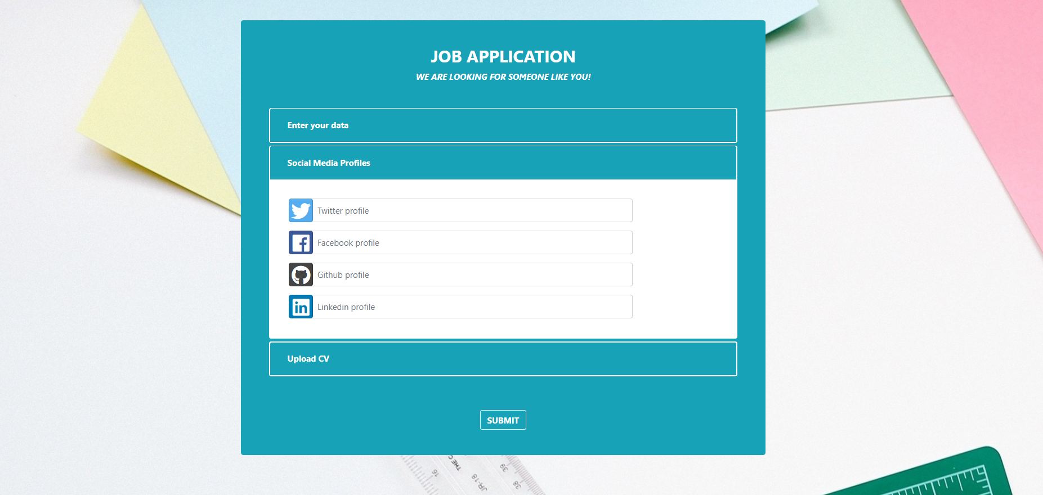

### Upload CV Section

This is the **third section**. It should have a **single input field**, with type – file.   
The **field** should be **styled** using the [Dropify](http://jeremyfagis.github.io/dropify/) plugin.

The **third section** shouldlookslikethis:

